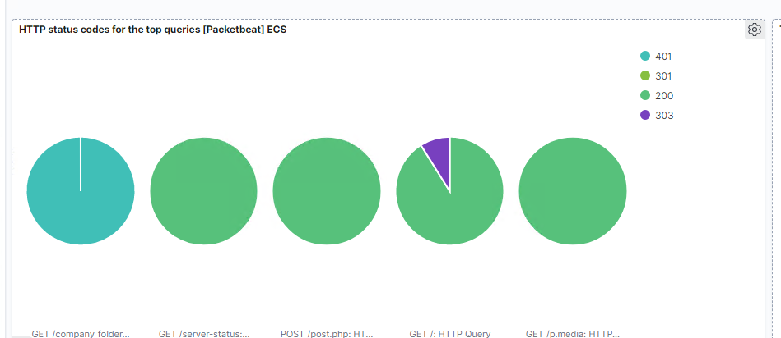

.01 of the request went through which means that something did get through.

That data is concerning because it means something went through.

-------------------------------------------------------------------------------------------------------------------------------

^ part 1

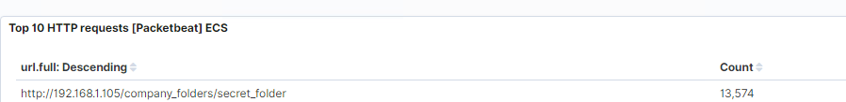

13,574

Company info

I would set an alarm for the amount of traffic they are getting.

Spin up a few more machines to balance out the load

---------------------------------------------------------------------------

Part 2

Yes

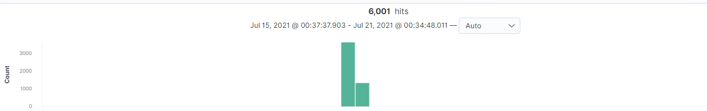

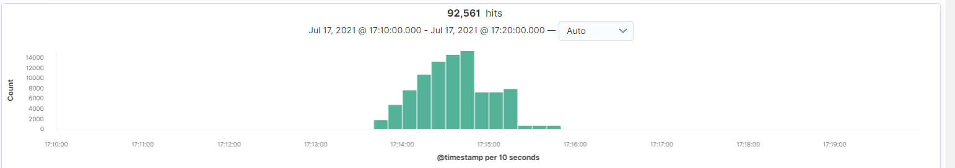

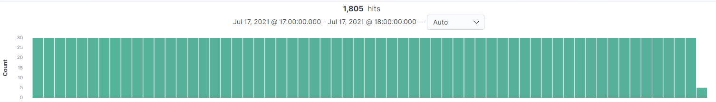

Excessive login attempts at 10 total

2 step authentication on the machines

^STEP 3

Step 4

No webdav results anywhere

Step 5

Yes you can

I would set an alert for an unauthorized login on port 443 or 80.

Keep data partitioned on a hidden drive or split data across multiple places.